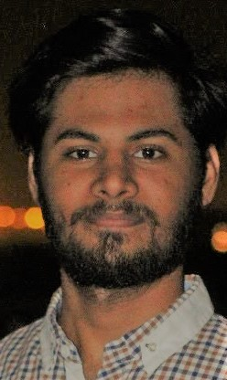 |  |  |  | MUSLIM ABUZAR

Experience:

I have done 8 months job in RA JOKHIYO (PVT) ltd as an Assistant Accountant.
I have done 2 months job in LEADS CALL CENTER as a Service provider.

I am Front end Web developer at Freelance market.

Education:
[Secondary School Certificate]
- S.M Public Academy School Karachi (2015)

[Higher Secondary Certificate]
- PAF Intermediate College Masroor, Karachi (2016-2018)

[Graduation]
- Deed Bachelor’s in Computer Science in Iqra University

OBJECTIVE:
Looking for a challenging role in a reputable organization to utilize my technical, database, and management skills for the growth of the organization as well as to enhance my knowledge about new and emerging trends in the Web development and IT sector.

PERSONALITY ATTRIBUTES:
Team player, ready to work under pressure, flexible, honest, hardworking and good at communication, able to react effectively under stress and emergencies. Seeking position that would utilize my skills and challenge my various abilities. Looking for an organization that offer career growth and a chance to achieve goals through persistence and hard work.

OTHER SKILLS AND CERTIFICATE:
- Diploma in Information System Management
From Aptech Institute.
- Diploma of Electrical Engineering.
- Chinese language course from Pak China Institute.

INTEREST:
Reading, Music ,Sports & Computers

COMPUTER SKILLS:
[Address]
Rose Garden E-58 Gulistan-e-johar block # 13, Karachi, Pakistan
 |  | Cell #: 0303-2946848
 |  | Email: muslimabuzar@gmail.com
- Data Base Management System in PHP, MYSQL server.
- MS-OFFICE, Power point, Word, Excel.
- Make Websites in E-commerce, portfolio, business & blog sites.
- Command in making Static websites as well as Dynamic sites.

PROJECTS:

- E-commerce Website (Project of the month August in Aptech Institute).
- I have done portfolio websites and static websites.
- I have done blogging sites also.

COMPUTER LANGUAGES:

HTML5, CSS3, JAVASCRIPT, BOOTSTRAP, C++

REFERENCE:

Provided upon request

