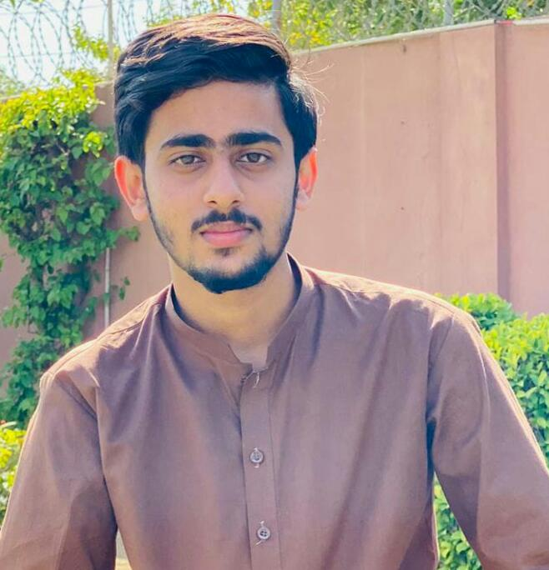 |  |  |  | Muhammad Shayan Shahbaz
I am potentially learning in my field to enhance my skills facing different challenges.A quick learner,an enthusiastic person always passionate to work smart.Looking forward to proving my mettle and building an experience by pursuing opportunities in the working environment through internships where I can face new challenges while effectively learning and enhancing my skills, full potential to be an asset to any organization in any field.

Education
DHA SUFFA UNIVERSITY (BSCS), Karachi Pakistan
- 2020 To 2024 (Currently in 6th semester)
Jinnah Government College (PreEngineering), Karachi Pakistan
- 2018-2020
Nasra School Main Campus (Science), Karachi Pakistan
- 2016-2018

Skills
- Trained on programming software’s like VS,DevC++
- Languages learned in university (HTML,CSS,JAVASCRIPT,C,C++,JAVA,ASSEMBLY LANGUAGE,LINUX,SQL)
- Skilled on MS word, PowerPoint and Excel
- Computer Skills
- Leadership qualities
- Management skills
- Time management

 |  | Garden East
 |  | 03243238331
 |  | shayankhan2002@yahoo.com

