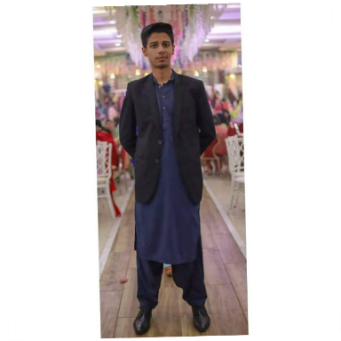
CONTACT
03301252235
Karachi, Pakistan
SKILLS
Microsoft Word Microsoft Excel Java Language Time Management Verbal & Written Communication
LANGUAGE
English

Urdu

FARIS AHMED SIDDIQUI

PROFILE STATEMENT:
FATHER NAME: IQBAL AHMED SIDDIQUI CNIC NO:42201-4676153-7
EMAIL: farissdidiqui865@gmail.com

PERSONAL STATEMENT:
Passionate and hospitable about the customer service. Hard working and enthusiastic for the job. Want to experience new fields and will work hard to obtain a position that will utilize my dedication to organization’s needs and development and increase my performance through creativity and high order- thinking.

WORK EXPERIENCE:
RJ BPO Solutions experience of 8 months.
Inbound and Outbound CSR
D CACTUS experience of 2 months.
Outbound CSR
PRODIGY SOLUTIONS
11 months.

EDUCATION:

UNDERGRADUATE(Software Engg. 5th SEM)
Sir Syed University of engineering & technology

INTERMEDIATE
Bahria College Karsaz Pre- Engineering

MATRICULATION
Shaheen Public School

- CERTIFICATES
Having Certification in Data Structures & Algorithms.
Excellent Handgrip in Java.
Currently doing Web & App Development(HTML & CSS DONE)

