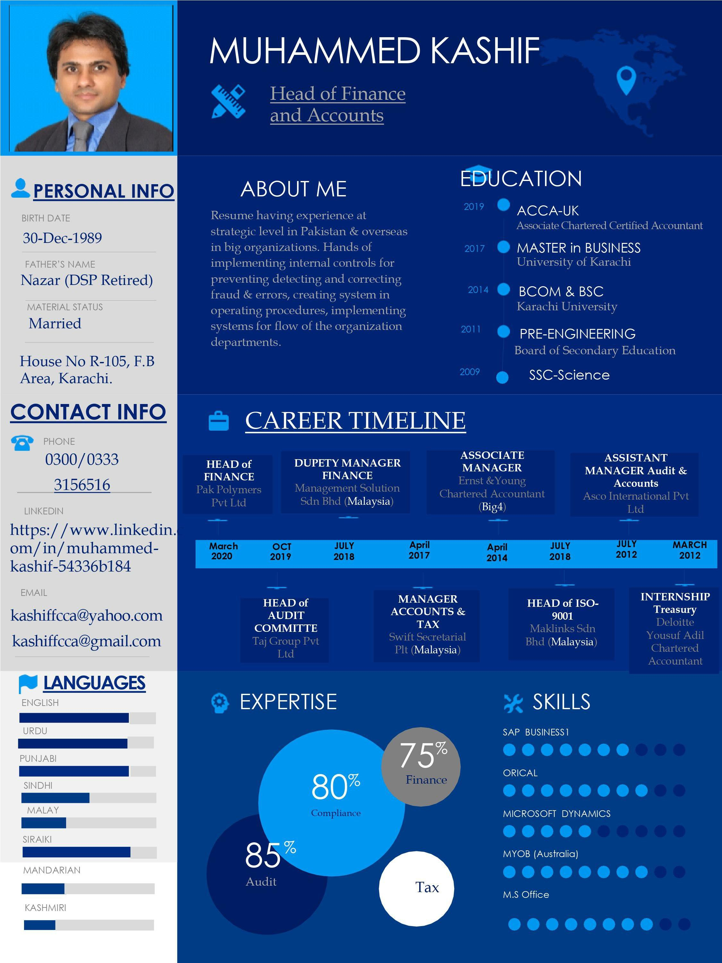

Pak Polymer Pvt Ltd:  Head of Accounts and Finance  (March 2020 till Present) | - Created internal controls into the organization of all the major operation of company.  - Created system of maintaining stock of over 55 sort of material in 35 warehouses date by date.  - Corrected existing software all ledger, accounts head, entries, into chart of account.  - Finding the best software suitable for trading company and interact with software house for implementation into business.  - Implemented SAP into the business for two branches and classify the cost and revenue for both sites.  - Created chart of account for with classification sales, cost of sales and expenses for two branches.  - Created standard operating procedures of procurement, stock storage, carriage/cartridge, import, HR and office operations.  - Participating in AGM presenting directors about performance of business periodically and making the planning for next financial year raise in sales and reduction in cost of sales, expansion of business and its operation.  - Took respective actions to increase in business raise in sales and achieve 300% sales growth in less than one year.  - Identifying all financial and non-financial factors of both companies.  - Have keen observation of paying minimum corporate taxation of group as a whole.  - Created many internal documents for collection of data from customer vendor transporters and forwarding agencies.  - Created data management system for two different private limited companies.  - Created complete company HR policy with respect designation, basic pay, over times, allowances, benefits and deductions.  - Created internal control of all departments, procurement, sales & marketing, warehouse, for the prevention of fraud, detection of fraud correction with the help of internal controls, and correct errors and mistakes to make the system effectively and efficiently.
Taj Group Pvt Ltd  Head of Audit Committee  (Oct-2019 to Feb-2020) | - Perform audit procedures of over 67 sites of the company.  - Perform substantive procedure of financial statements of four private limited companies under single director.  - Reconciliation of branch sales with site bank account, site ledger with head office software ledger.  - Ensure that all payments are as per policy and approval by respective authorized person.  - Ensure all statutory payment are made timely basis with records.  - Reconciliation of four bank accounts of three group of companies.  - Reconciliation of stock of all 67 sites, with site ledger, physical stock, and head office records.  - Cost reconciliation of every new start up site for over total cost of Rs.300 million.  - Perform audit procedure of operation/procurement department whether any fraudulent activity, over or wrong payment is involved.  - Provide professional guideline to finance, HR, operation, sales/marketing department under the policy of organization.  - Perform audit procedure of staff over 400 employees, labour, and office staff for all the sites.

- Perform financial statement verification of over 67 sites of each and every single component of income statement from sales to cost of sales, operating and administrative expenses.
- Ensure that actual cost should be as per budgeted standard allocated to newly started branch and finding whether any over payment is made.
Management Solutions Sdn Bhd (Malaysia)  Deputy Manager Accounts & Finance  (July-2018 to Oct-2019) | - Accountable for quarterly financial statements for two group companies.  - Responsible for comparative financials for last five years and give the presentation to BOD’s.  - Calculation of salary over 300 employees, ensuring that correct deduction allowances and advances have been charged to each employee.  - Performing the cost function of over 30 projects of the entity, and assessing whether the project is feasible for the company.  - Assessing and supporting other departments lower staff for company accounting and finance practice and compliance with accounting function as per international financial reporting standard.  - Performing audit of HR function of over 300 employees making sure that correct payment was made after deduction allowance and advances, that’s major proportion of financial  - Ensuring correct amount is being paid to vendor with supporting documents, as per credit payment period.  - Audit of all Cost related to client, Revenue and Expenses with respect to Trial Balance and supporting Documents.  - Submission income tax on periodic basis & GST submission.  - Managing the inventory with different types and category and updating with respect to issue and purchase of new stock.  - Preparing records of asset for over 30 projects of the entity and preparing asset management of all the sites of company.  - Implementation of internal control system in organization regards HR, Production Sales, Cost & Inventory.  - Ensuring that staff correctly prepares Purchase Order, Goods receive note, invoice, payment voucher, proceeding payments to nation and overseas vendors.  - Preparing the balance sheets, assets & liabilities, and profit and loss accounts and assess the true financial position of the organization on software.  - Enable to generate profit and loss arrived on each project for the project feasibility with regards to company.  - Maintaining petty cash of over 20 sites separately and account for into the costing of project on monthly basis.  - Preparing the schedule of noncurrent leased assets and entity owned assets and any adjustment required.  - Managing the cash flow of the entity on daily basis and analyzing funds at the month ended and preparing statement of cash flow and reconcile with balance at bank.  - Coordinate activities between the organization and the Director for successful accounts, HR, Tax & Finance Operations.  - Verify the supporting documents/Voucher of bills, receipts and prepare bank reconciliation statements.  - Ensured compliance with all applicable laws, regulations, codes, ordinances and standards.  - Evaluated the effectiveness and efficiency of compliance with, internal controls and operating procedures.  - Managing funds of organization as per IAS7 cash flow statement.  - Compute the tax liability of company & support the organization in making tax returns on time basis.

Maklinks Sdn Bhd (Malaysia)  Head of ISO-9001  (July-2018 to Oct-2019) | - Responsible of performing all ISO-9001 standard requirements.  - Responsible for all Operations as per Prescribed ISO- 9001 Standard for Company as a Whole.  - Giving presentation to BOD’s on quarterly basis on the entire ISO-9001 requirement.  - Protection of organization confidential records and access only to top management.  - Ensuring all the books of accounts is properly prepared.  - Preparing all stakeholders personal data with their respective file.  - Preparation of customer data and breakup their amount into different heads as per prescribed by ISO-9001.  - Audit of manual records like register PO summery, attendance of all employees on software and manual.  - Performing, conducting annual audit with audit team participating with team for new task assigned by ISO team head.
Swift Secretarial Plt (Malaysia)  Head of ISO-9001  (April-2017 to July-2018) | - Prepare full set of accounts of over 60 Sindrian Berhad (Private Limited Companies) & Enterprise companies on accounting software.  - Responsible for recording purchases, Sales (with GST & Non GST) Cost of Sales, Operating Expenses for the year.  - Audit of all Cost, Revenue and Expenses with respect to Trial Balance and supporting Documents.  - Submission of income tax on quarter basis & GST submission online to Government authorities.  - Implementation of internal control system in organization regards HR, Production Sales & Inventory.  - Responsible for creating Purchase Order, Goods received note proceeding payments to nation and overseas vendors on accounting software.  - Preparing the balance sheets, assets & liabilities, and profit and loss accounts display the true financial position of the organization on software.  - Reconciliation of debtors & creditors ledgers on accounting software and find the net amount to / net amount due from customers and suppliers.  - Provide the professional guideline to the clients for improving their system and tax saving.  - Preparing console relating to all export consignments and import raw material and recording related all costs into the system prior experience in logistic company.  - Adjusting vendor & customer ledger on periodic basis and making adjustment any required.  - Enable to generate profit and loss arrived on each consignment to and adjusted with general ledger.  - Able to audit all payroll office staff labor workers with deduction and allowances on ERP software.  - Preparing the schedule of noncurrent leased assets and entity owned assets and any adjustment required.  - Enable to prepare profit arriving on each individual consignment to overseas customer.  - Managing the cash flow of the entity on daily basis and analyzing funds at the month ended and preparing statement of cash flow and reconcile with balance at bank.  - Coordinate activities between the organization and the Director for successful accounts, HR, Tax & Finance Operations.  - Verify the supporting documents/Voucher of bills, receipts and prepare bank reconciliation statements.  - Ensured compliance with all applicable laws, regulations, codes, ordinances and standards.  - Performing HR function of calculating monthly taxable/nontaxable salaries of over 80 employees of the client.  - Ensured that cash is handled as per prescribed rules, and established procedures.  - Evaluated the effectiveness and efficiency of compliance with, internal controls and operating procedures.  - Managing funds of organization as per IAS7 cash flow statement.  - Compute the tax liability of SDN BHD & support the organization in making tax returns on time basis.

Ernst & Young  Chartered Accountant firm  Audit Senior  (April-2014 to Mar-2017) | - Performing the audit of audit client for task assigned by job in-charge.  - Audit procedure of stock count and reconcile the physical stock with system and provide guideline if required.  - Preparing schedule of non-current and assets make necessary adjustment if required by IFRS.  - Ensure that during audit procedures are adopted to detect fraud by management (if any), and correct accordingly.  - Provide the guideline to client for improving the improving its operations for better control system.  - Ensuring that necessary substantive procedures are performed on sales, costs of sales, administrative expenses, salaries & allowances, out of pocket expenses, capital & revenue expenses, petty cash expenses, all necessary deposits and withdrawals, into company’s account during audit.  - Ensure all mandatory government payments are made during the financial year.  - Finalizing the accounts before the deadline as per ISAs.  - Recording complete financials of overseas office on SAP.  - Recording of out of pocket expenses, JV’s & cash payments.  - P0sting of all Afghanistan Office expenses on ERP software.  - Periodic audit of inventory held with staff office and find variance physical with actual.  - Preparing Annual Budget of Afghanistan subsidiary with partner Bashir Juma Sab.  - Participate with audit team in preparing complete financial statements on of 6listed companies and over 15 private limited companies.  - Preparation of Memorandum of Association and Article of Association and perform mandatory function of company secretary with qualified chartered accountant.  - Inventory reconciliation of nationwide branches of client of different material item of FMCG.  - Performed all audit procedures on services entities and made their accounts as per IFRs.

Corporate Responsibility (Credit Risk Management):

- Incorporation of Company have knowledge of Company Ordinance 1984,
- Preparation of Memorandum of Association and Article of Association per Malaysian ordinance.
- Annual Filling Regard Change of Company Staff Director, Secretary, Chief Accountant at SSM.
- Remember Clients timely response regarding quarries related to Amendments in company ordinance of Malaysia.
- Registration of Charge, Mortgage, Search Reports and Certified true copies of stake holders.
- Annual Filing of from 29(Changes of Particular and staff), From A, change in company Security Exchange Commission Pakistan.

Interests:
- Playing basketball, Guitar, National Geographic, Historic movies, browsing on Internet.

References
Will be furnish upon request.
Achievements
- Achieving scholarship on getting highest marks Management Accounting in 2014.
- Workshop in Karachi Stock Exchange in 2014
- Won first prize in Project of Computer in DHA College.

